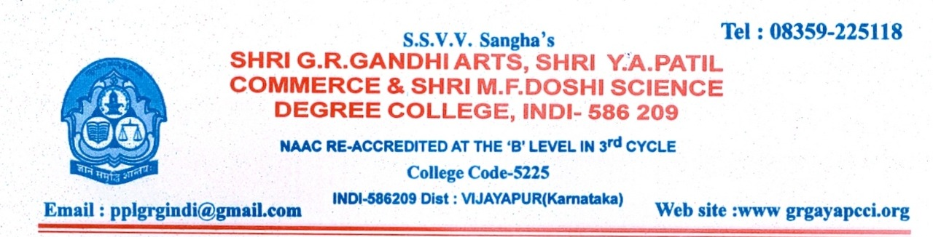
2019-20
7.3. Institutional Distinctiveness
Title: Introduction of e-mode of teaching/learning and evaluation

Description:

The academic year 2019-20 restricted the teaching activities due to covid-19. The college was not fully able to meet the requirement of teaching e-learning modes. The process required, in the first place, to train the faculty who have not used it, as also the students. Additionally, some more communication devices like the zoom app were to be acquired so that the students can be brought into “virtual classroom mode”, although most of them were at their residencies, mostly in remote villages.
With the guidance provided by the management, the staff took this task to their heart. They created subject-wise class groups by allotting links.
This system of e-learning did pave an easy path for the students to learn and understand the subject, and answer the questions in virtual mode.
The whole exercise was done in a filament of the college motto which is “Knowledge leads to peace and prosperity”.
This has been the distinctive achievement of the college, by overcoming all the obstacles in terms of making teachers hone their skills with new technology and making students participate in learning remotely.
The biggest achievement of this exercise is that now, the students are enthused to adapt their mode of learning even with offline classes with greater vigor.

